Download the new NX client from http://www.nomachine.com
Install the client application and run it.
The application should look similar to the one shown below.

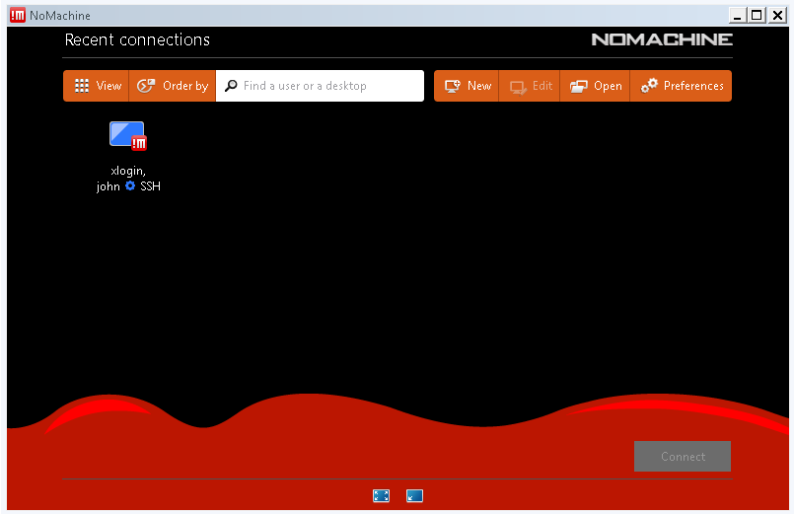

Click “new” to add a new connection.
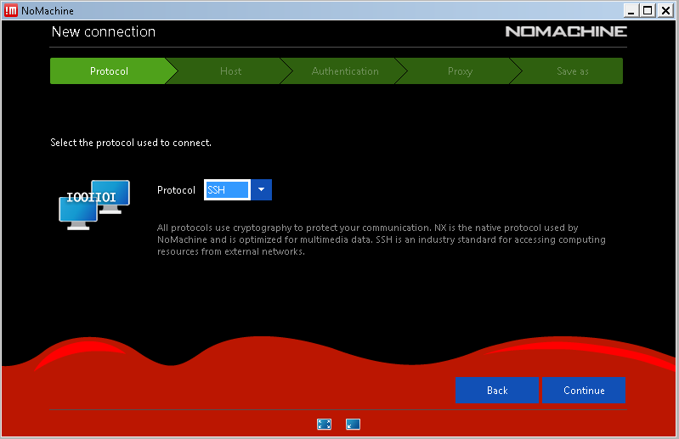
For now only the “SSH” protocol is supported, please select “SSH” in the dropdown menu.

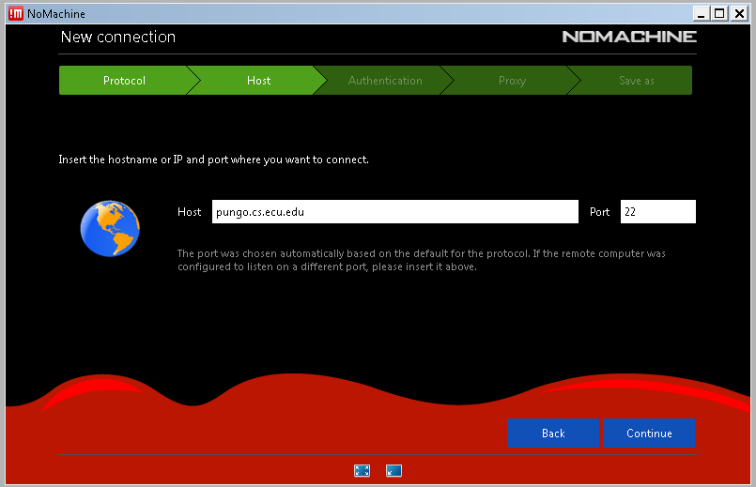

Enter the host name (or IP), leave the port set to the default of 22.

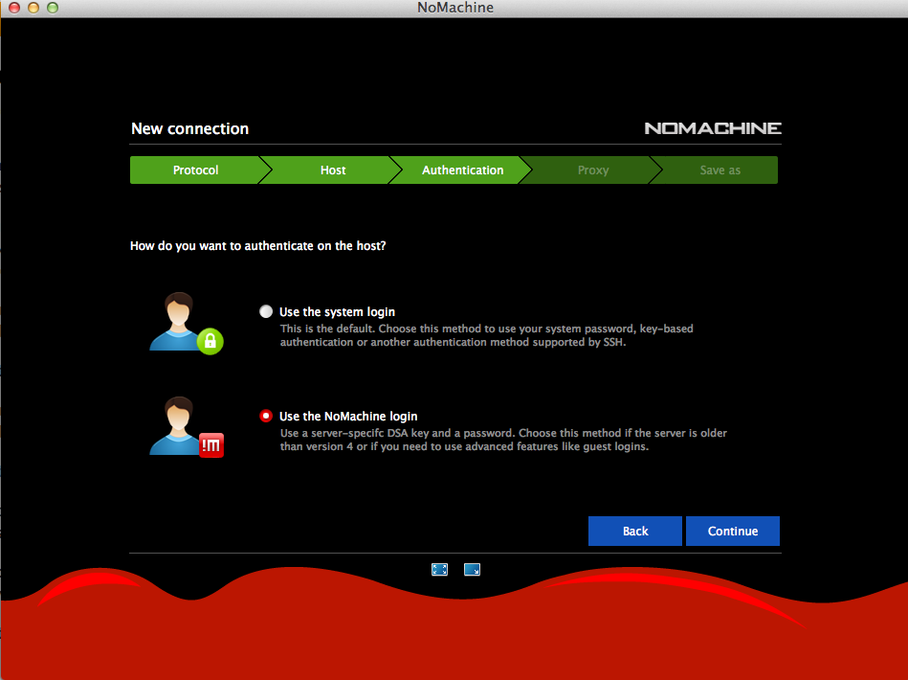

Keep the default value for the next three screens. The defaults are: “Use the NoMachine login”, “Password”, and “Don’t use a proxy” options.

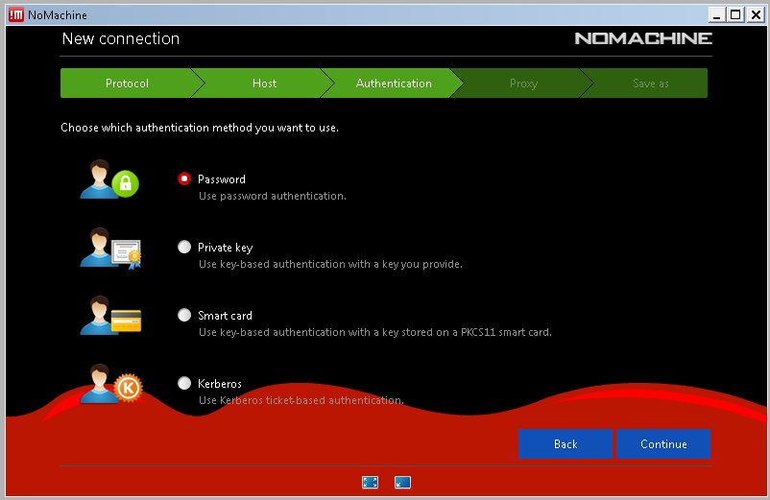
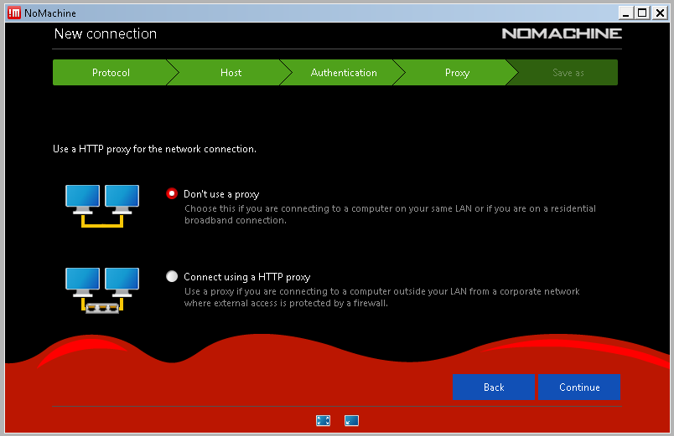

Name the connection anything you like; the default is fine in most cases.
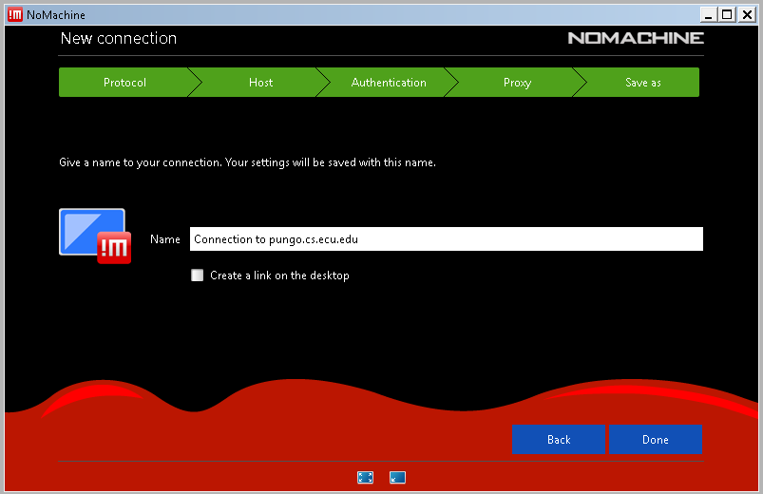

After clicking “Done”, the new connection will be displayed.
To connect, select the connection and click “Connect”.

